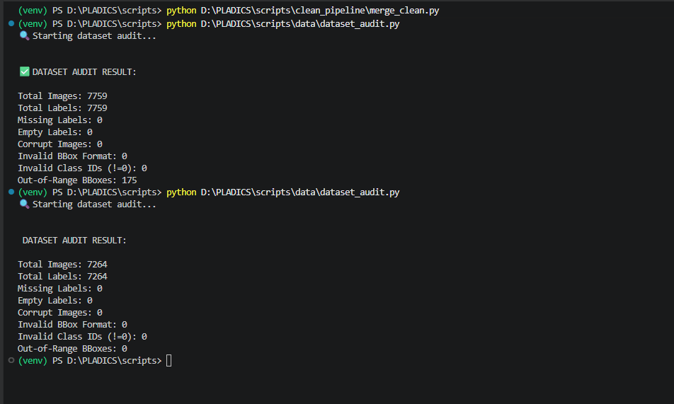

Validation results:
yolo detect train model=D:/PLADICS/yolo26n.pt data=D:/PLADICS/datasets_clean/merged_clean_dataset/plastic_clean.yaml epochs=50 imgsz=640 batch=8 device=cpu workers=0 project=D:/PLADICS/experiments_clean name=yolo26n_clean
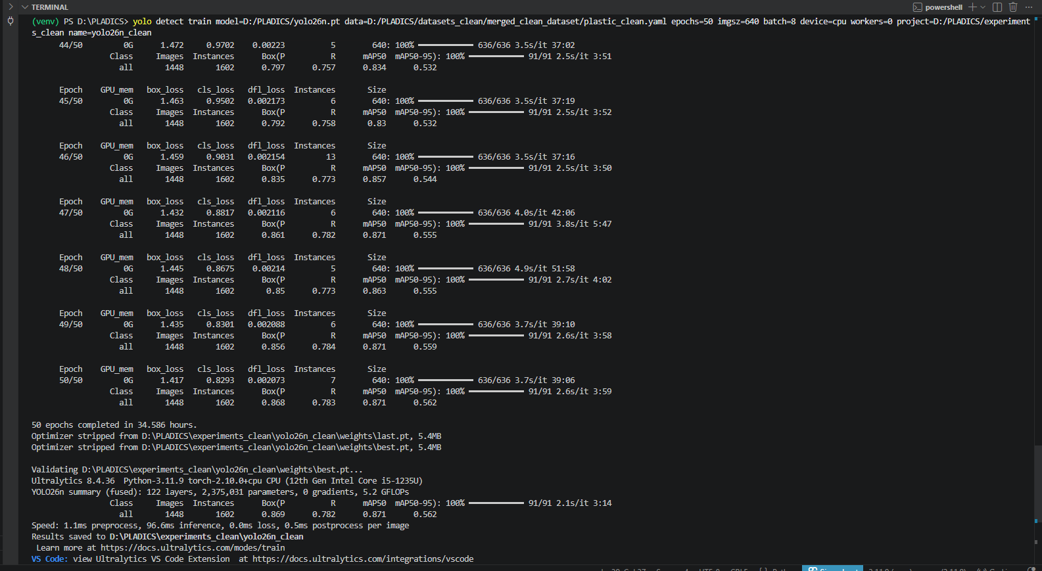

Precision:0.869
Recall:0.782
mAP50:0.871
mAP50-95:0.562

Validate test set:
yolo detect val model=D:/PLADICS/experiments_clean/yolo26n_clean/weights/best.pt data=D:/PLADICS/datasets_clean/merged_clean_dataset/plastic_clean.yaml split=test imgsz=640 batch=8 device=cpu project=D:/PLADICS/experiments_clean name=yolo26n_clean_test

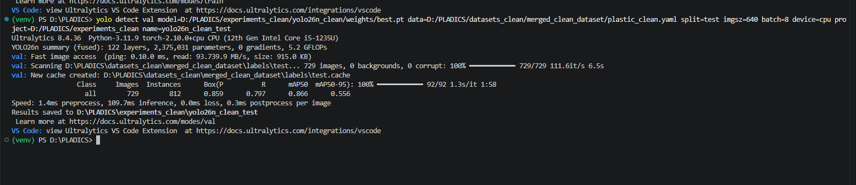

Precision:0.859
Recall:0.797
mAP:0.866
mAP50-95:556

Training command:
yolo detect train model=D:/PLADICS/yolo26s.pt data=D:/PLADICS/datasets_clean/merged_clean_dataset/plastic_clean.yaml epochs=50 imgsz=640 batch=8 device=cpu workers=0 project=D:/PLADICS/experiments_clean name=yolo26s_clean

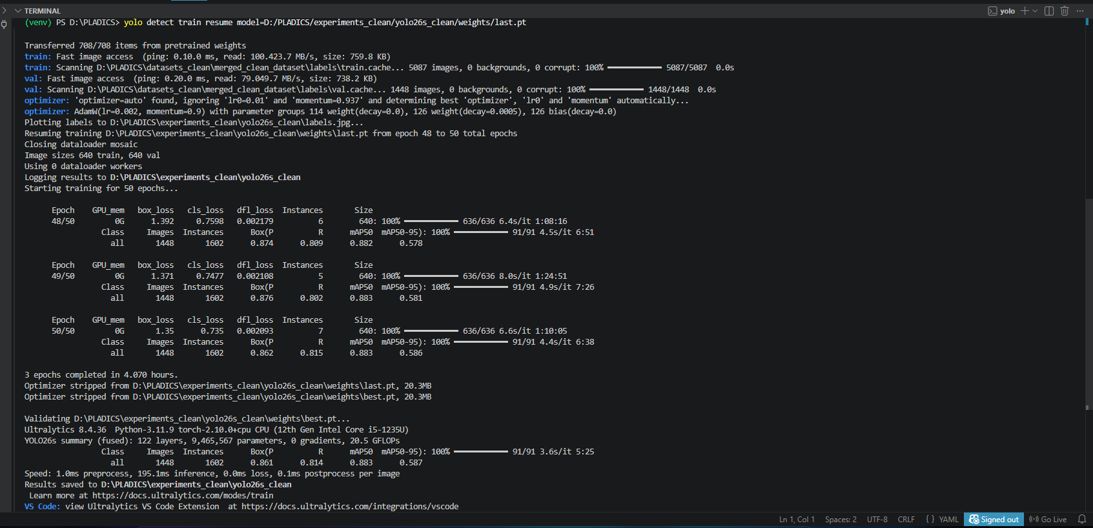

Precision (P) ≈ 0.861
Recall (R) ≈ 0.814
mAP@0.5 ≈ 0.883
mAP@0.5:0.95 ≈ 0.587
Model size ≈ 20.3 MB

Validate test set:
yolo detect val model=D:/PLADICS/experiments_clean/yolo26s_clean/weights/best.pt data=D:/PLADICS/datasets_clean/merged_clean_dataset/plastic_clean.yaml split=test imgsz=640 batch=8 device=cpu project=D:/PLADICS/experiments_clean name=yolo26vs_clean_test
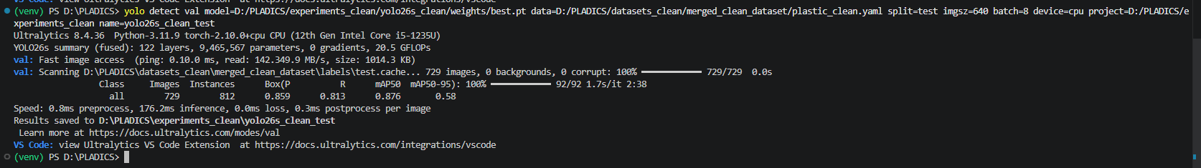

Precision (P) = 0.859
Recall (R) = 0.813
mAP@0.5 = 0.876
mAP@0.5:0.95 = 0.580

Training command:
yolo detect train model=yolo11n.pt data=D:/PLADICS/datasets_clean/merged_clean_dataset/plastic_clean.yaml epochs=50 imgsz=640 batch=8 device=cpu workers=0 project=D:/PLADICS/experiments_clean name=yolo11n_clean

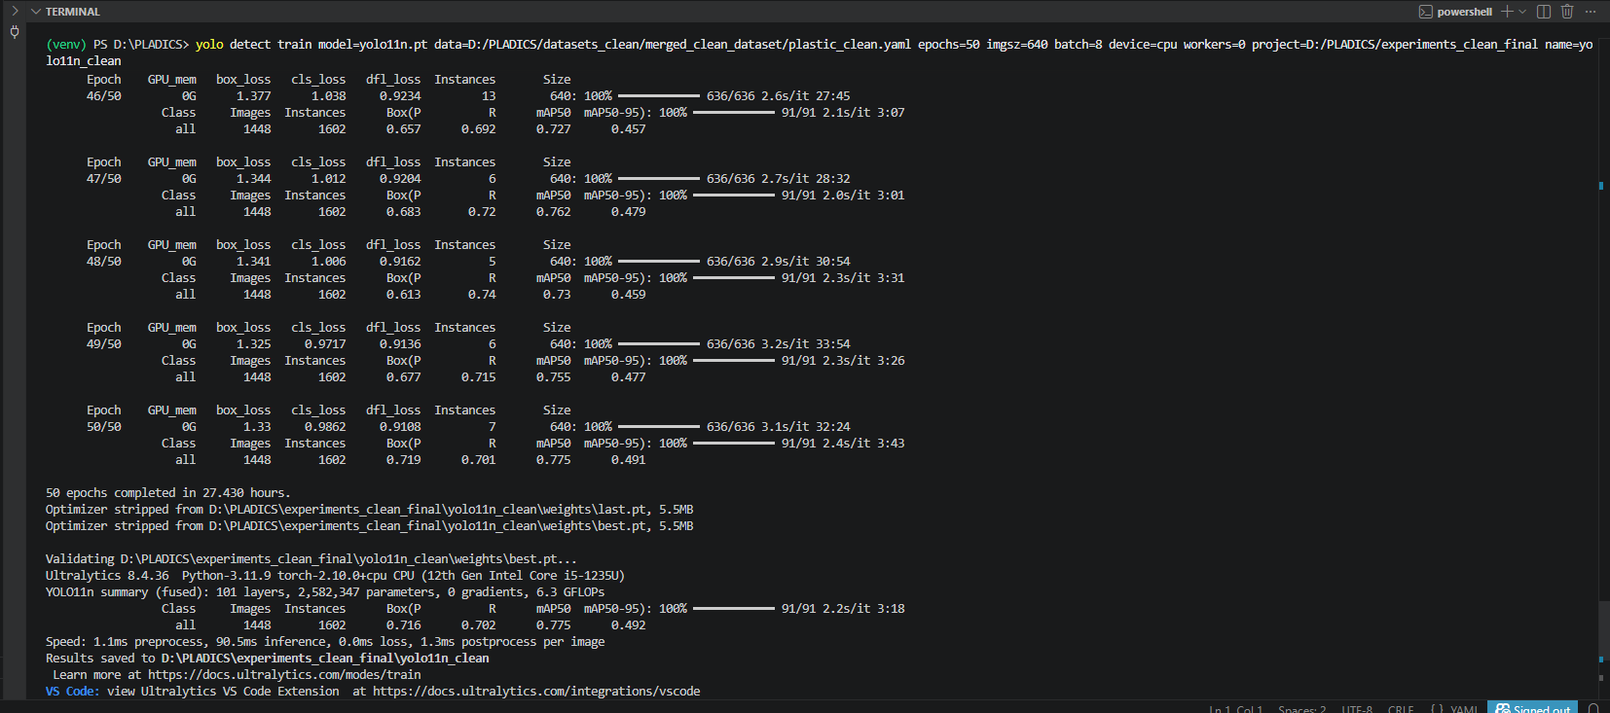

Precision:0.716
Recall:0.702
mAP:0.775
mAP50-95:492

Validate test set:
yolo detect val model=D:/PLADICS/experiments_clean/yolo11n_clean/weights/best.pt data=D:/PLADICS/datasets_clean/merged_clean_dataset/plastic_clean.yaml split=test imgsz=640 batch=8 device=cpu project=D:/PLADICS/experiments_clean name=yolo11n_clean_test
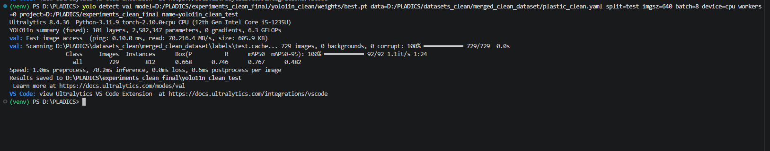
Precision:0.668
Recall:0.746
mAP:0.767
mAP50-95:482

Training command:
yolo detect train model=D:/PLADICS/yolo26n.pt data=D:/PLADICS/datasets_clean/RiSID_2class_clean/dataset.yaml epochs=50 imgsz=640 batch=8 device=cpu workers=0 project=D:/PLADICS/experiments_multiclass_clean name=risid2_yolo26n
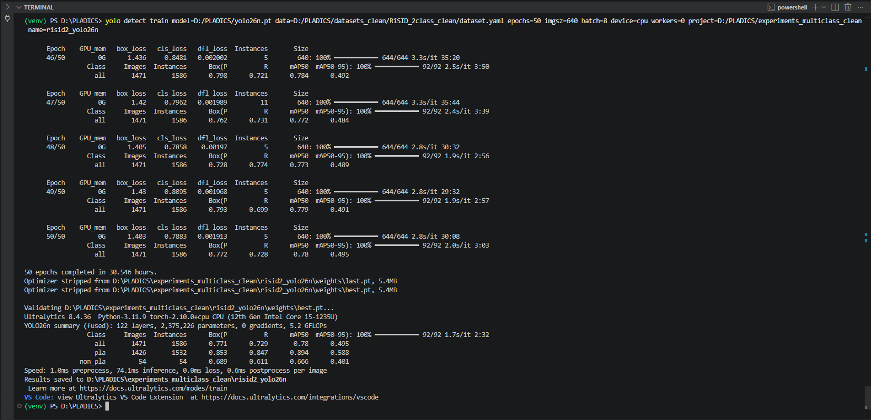

Validate test set:
yolo detect val model=D:/PLADICS/experiments_multiclass_clean/risid2_yolo26n/weights/best.pt data=D:/PLADICS/datasets_clean/RiSID_2class_clean/dataset.yaml split=test imgsz=640 batch=8 device=cpu workers=0 project=D:/PLADICS/experiments_multiclass_clean name=risid2_yolo26n_test
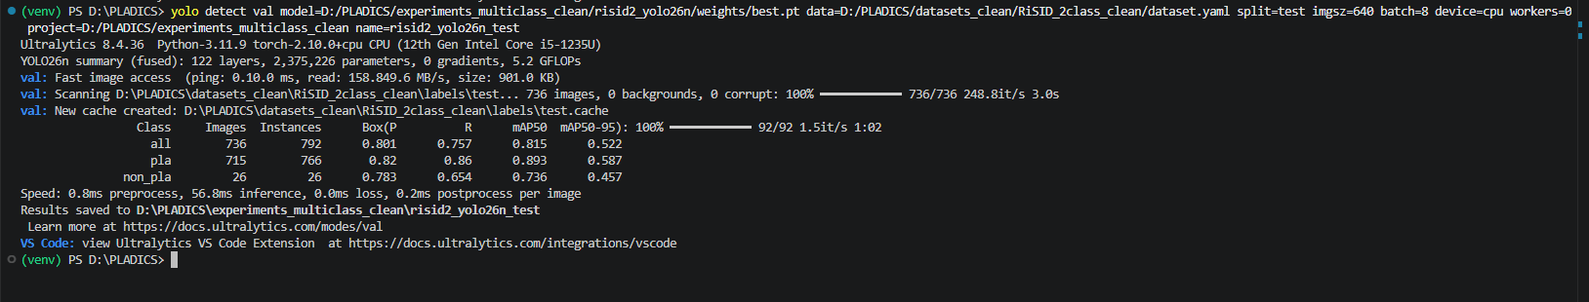
all class Precision:0.801
All class Recall:0.757
All class mAP:0.815
All class mAP50-95:0.522

pla class Precision:0.82
pla class Recall:0.86
pla class mAP:0.893
pla class mAP50-95:0.587

Non_pla class Precision:0.783
Non_pla class Recall:0.654
Non_pla class mAP:0.736
Non_pla class mAP50-95:0.457

Training command:
yolo detect train model=D:/PLADICS/yolo26n.pt data=D:/PLADICS/datasets_clean/RiSID_5class_clean/dataset.yaml epochs=50 imgsz=640 batch=8 device=cpu workers=0 project=D:/PLADICS/experiments_multiclass_clean name=risid5_yolo26n
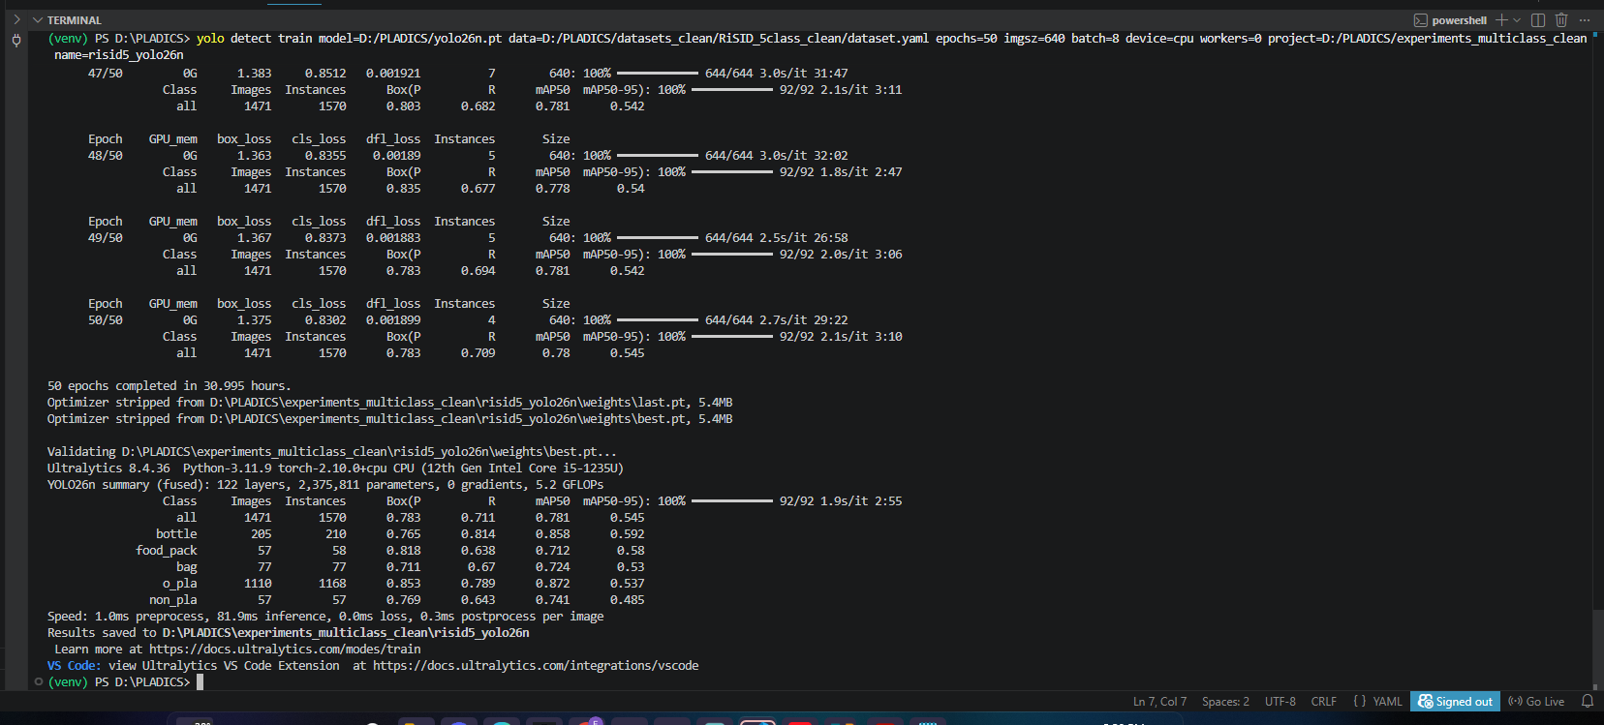

Validate test set:
yolo detect val model=D:/PLADICS/experiments_multiclass_clean/risid5_yolo26n/weights/best.pt data=D:/PLADICS/datasets_clean/RiSID_5class_clean/dataset.yaml split=test imgsz=640 batch=8 device=cpu workers=0 project=D:/PLADICS/experiments_multiclass_clean name=risid5_yolo26n_test

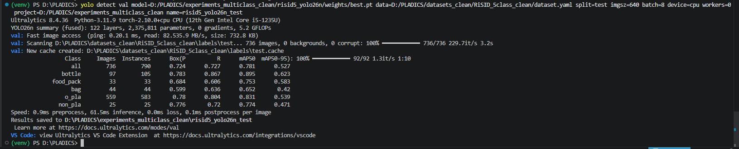
all class Precision:0.724
All class Recall:0.727
All class mAP:0.781
All class mAP50-95:0.527

bottle class Precision:0.724
bottle class Recall:0.727
bottle class mAP:0.781
bottle class mAP50-95:0.527

Food_pack class Precision:0.684
Food_pack class Recall:0.606
Food_pack class mAP:0.753
Food_pack class mAP50-95:0.583

bag class Precision:0.599
bag class Recall:0.636
bag class mAP:0.652
Bag class mAP50-95:0.42

O_pla class Precision:0.78
O_pla class Recall:0.804
O_pla class mAP:0.831
O_pla class mAP50-95:0.539

Non_pla class Precision:0.776
Non_pla class Recall:0.72
Non_pla class mAP:0.774
Non_pla class mAP50-95:0.471

Training command:
yolo detect train model=D:/PLADICS/yolo26n.pt data=D:/PLADICS/datasets_clean/RiSID_7class_clean/dataset.yaml epochs=50 imgsz=640 batch=8 device=cpu workers=0 project=D:/PLADICS/experiments_multiclass_clean name=risid7_yolo26n
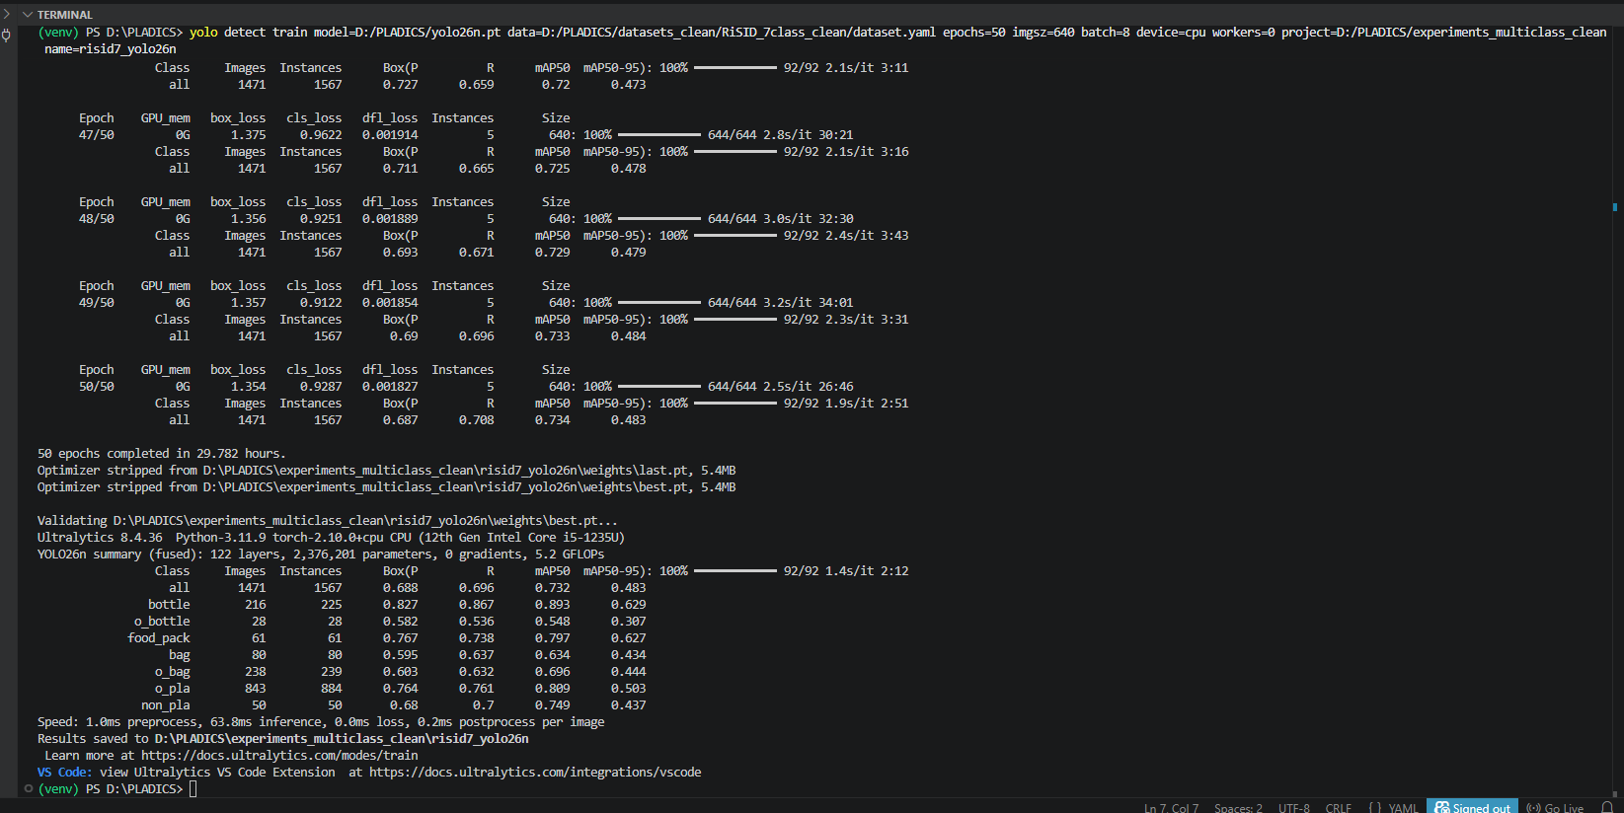

Validate test set:
yolo detect val model=D:/PLADICS/experiments_multiclass_clean/risid7_yolo26n/weights/best.pt data=D:/PLADICS/datasets_clean/RiSID_7class_clean/dataset.yaml split=test imgsz=640 batch=8 device=cpu workers=0 project=D:/PLADICS/experiments_multiclass_clean name=risid7_yolo26n_test
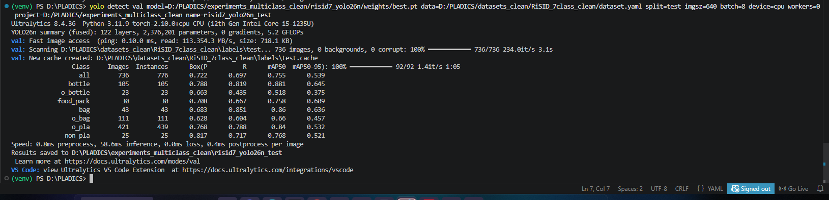

all class Precision:0.722
All class Recall:0.697
All class mAP:0.755
All class mAP50-95:0.539

bottle class Precision:0.788
bottle class Recall:0.819
bottle class mAP:0.881
bottle class mAP50-95:0.645

O_bottle class Precision:0.663
O_bottle class Recall:0.435
O_bottle class mAP:0.518
O_bottle class mAP50-95:0.375

Food_pack class Precision:0.708
Food_pack class Recall:0.667
Food_pack class mAP:0.758
Food_pack class mAP50-95:0.609

bag class Precision:0.683
bag class Recall:0.851
bag class mAP:0.86
Bag class mAP50-95:0.636

O_bag class Precision:0.628
O_bag class Recall:0.604
O_bag class mAP:0.66
O_bag class mAP50-95:0.457

O_pla class Precision:0.768
O_pla class Recall:0.788
O_pla class mAP:0.84
O_pla class mAP50-95:0.532

Non_pla class Precision:0.817
Non_pla class Recall:0.717
Non_pla class mAP:0.768
Non_pla class mAP50-95:0.521

Training command:
yolo detect train model=yolo26n.yaml data=D:/PLADICS/datasets_clean/RiSID_5class_clean/dataset.yaml epochs=50 imgsz=640 batch=8 device=cpu workers=0 project=D:/PLADICS/experiments_multiclass_clean name=risid5_yolo26n_scratch

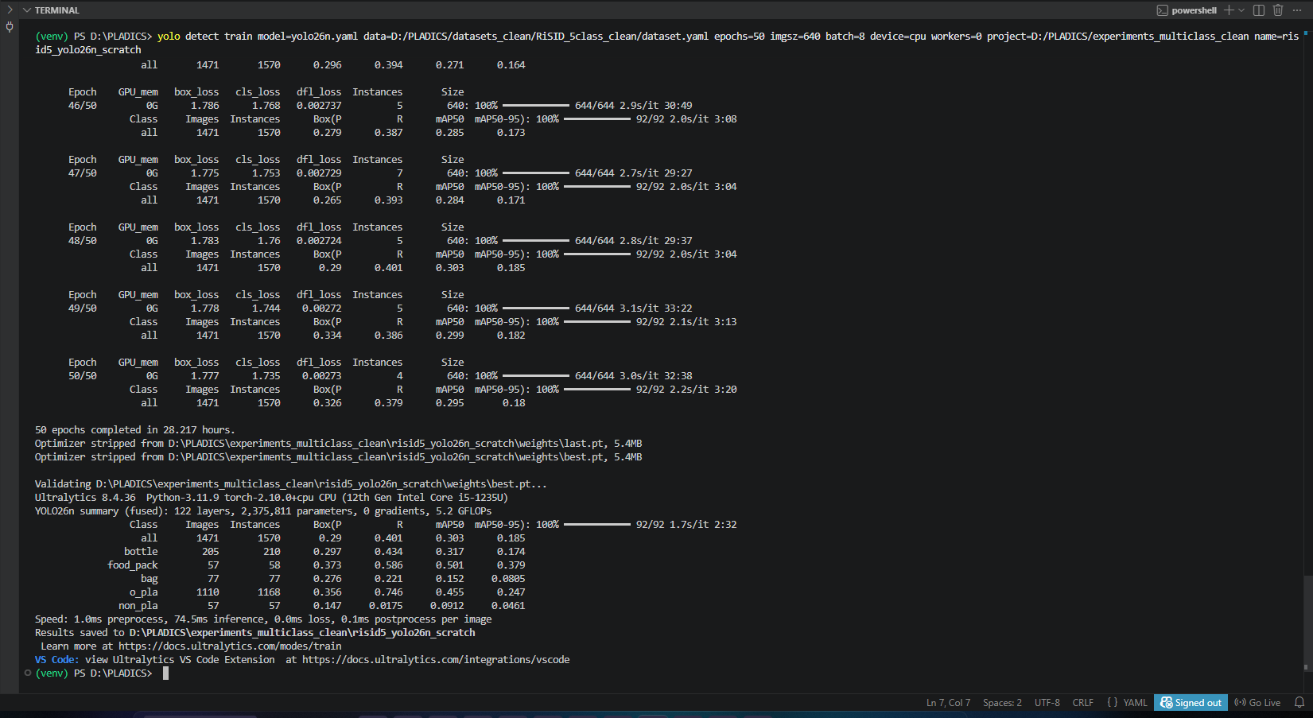

all class Precision:0.29
All class Recall:0.401
All class mAP:0.303
All class mAP50-95:0.185

bottle class Precision:0.297
bottle class Recall:0.434
bottle class mAP:0.317
bottle class mAP50-95:0.174

Food_pack class Precision:0.373
Food_pack class Recall:0.586
Food_pack class mAP:0.501
Food_pack class mAP50-95:0.379

bag class Precision:0.276
bag class Recall:0.221
bag class mAP:0.152
Bag class mAP50-95:0.0805

O_pla class Precision:0.356
O_pla class Recall:0.746
O_pla class mAP:0.455
O_pla class mAP50-95:0.247

Non_pla class Precision:0.147
Non_pla class Recall:0.0175
Non_pla class mAP:0.0912
Non_pla class mAP50-95:0.0461

Validate test set:
yolo detect val model=D:/PLADICS/experiments_multiclass_clean/risid5_yolo26n_scratch/weights/best.pt data=D:/PLADICS/datasets_clean/RiSID_5class_clean/dataset.yaml imgsz=640 batch=8 device=cpu

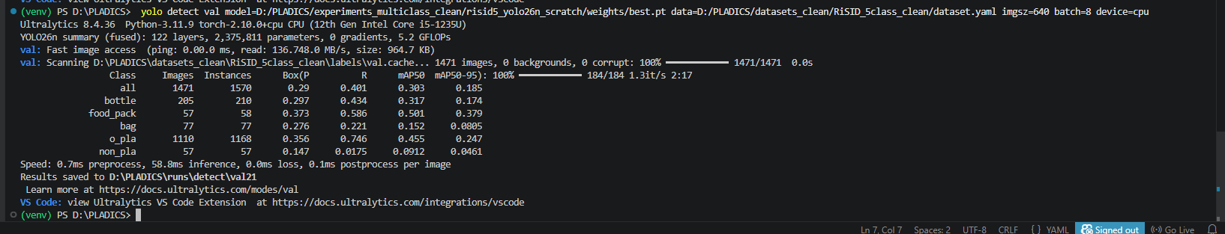
all class Precision:0.29
All class Recall:0.401
All class mAP:0.303
All class mAP50-95:0.185

bottle class Precision:0.297
bottle class Recall:0.434
bottle class mAP:0.317
bottle class mAP50-95:0.174

Food_pack class Precision:0.373
Food_pack class Recall:0.586
Food_pack class mAP:0.501
Food_pack class mAP50-95:0.379

bag class Precision:0.276
bag class Recall:0.221
bag class mAP:0.152
Bag class mAP50-95:0.0805

O_pla class Precision:0.356
O_pla class Recall:0.746
O_pla class mAP:0.455
O_pla class mAP50-95:0.247

Non_pla class Precision:0.147
Non_pla class Recall:0.0175
Non_pla class mAP:0.0912
Non_pla class mAP50-95:0.0461

Training command:
yolo detect train model=D:/PLADICS/yolo26n.pt data=D:/PLADICS/datasets_clean/merged_clean_dataset/plastic_clean.yaml epochs=100 imgsz=640 batch=8 device=cpu workers=0 project=D:/PLADICS/experiments_clean_final name=yolo26n_clean_100
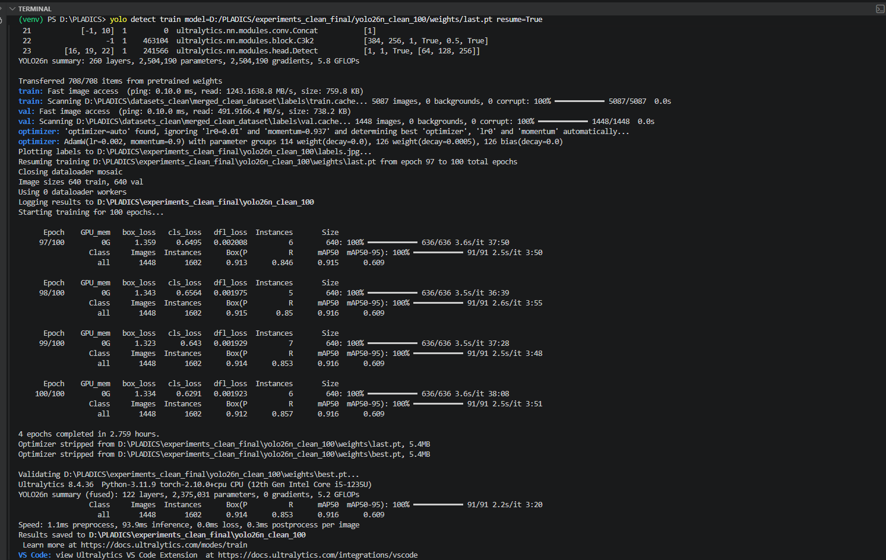

Precision:0.914
Recall:0.853
mAP:0.916
mAP50-95:609

Validate test set:
yolo detect val model=D:/PLADICS/experiments_clean_final/yolo26n_clean_100/weights/best.pt data=D:/PLADICS/datasets_clean/merged_clean_dataset/plastic_clean.yaml split=test imgsz=640 batch=8 device=cpu workers=0 project=D:/PLADICS/experiments_clean_final name=yolo26n_clean_100_test

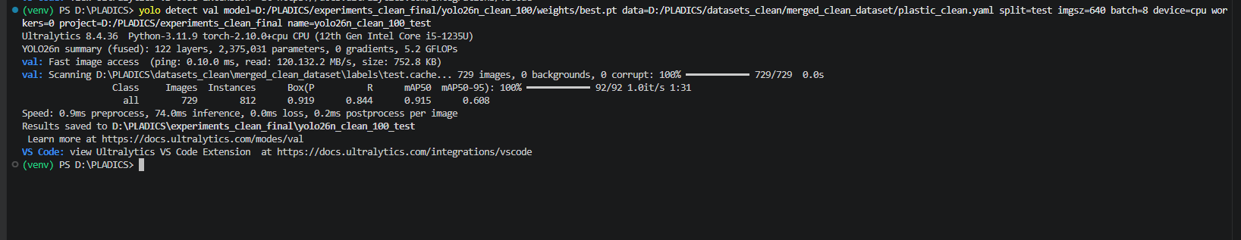

Precision:0.919
Recall:0.844
mAP:0.915
mAP50-95:608

yolo benchmark model=D:/PLADICS/experiments_clean_final/yolo26n_clean_100/weights/best.pt imgsz=640 device=cpu
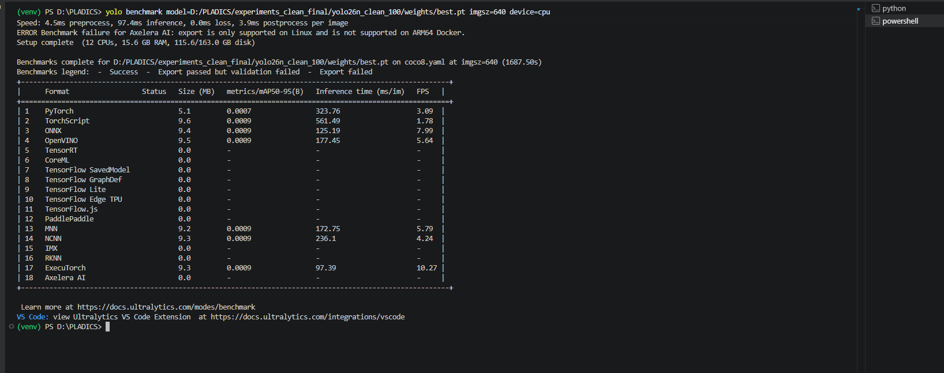
yolo benchmark model=D:\PLADICS\experiments_clean\yolo26s_clean\weights\best.pt imgsz=640 device=cpu
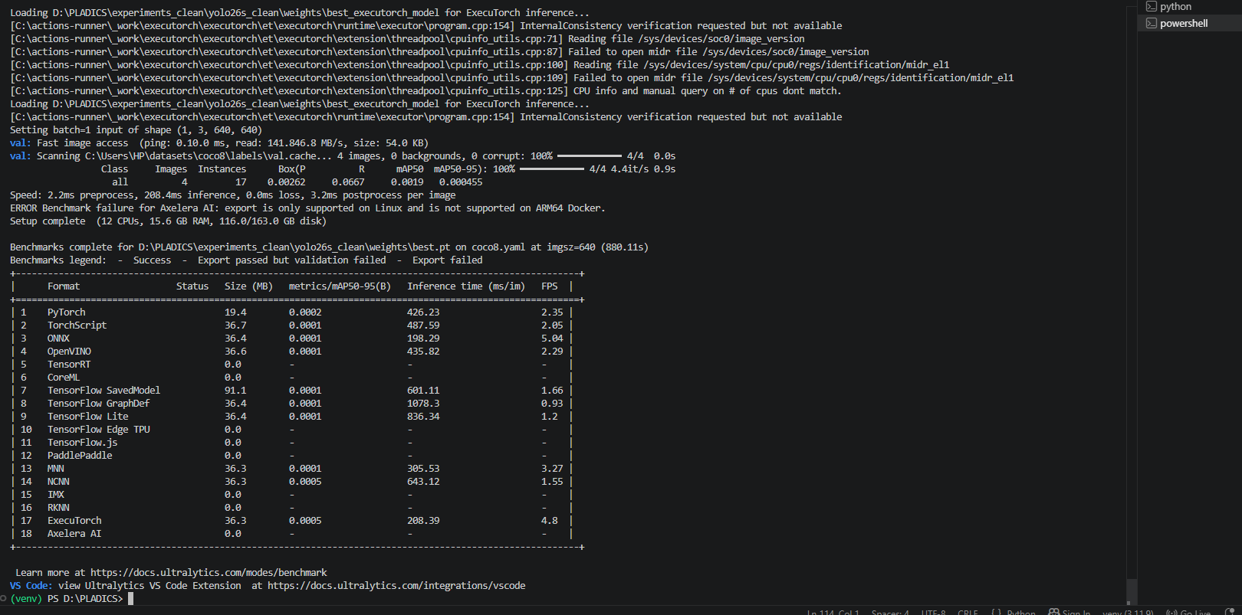

4 Fold Cross Validation

1st fold result:
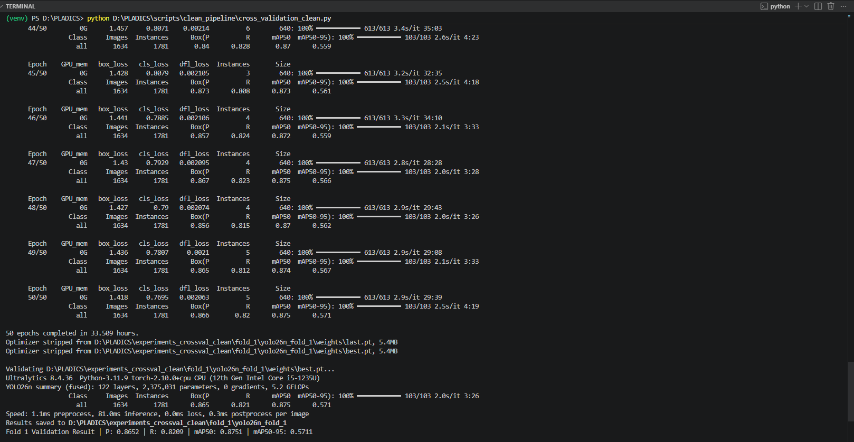
Precision:0.8652
Recall:0.8209
mAP:0.8751
mAP50-95:0.5711

2nd fold result:
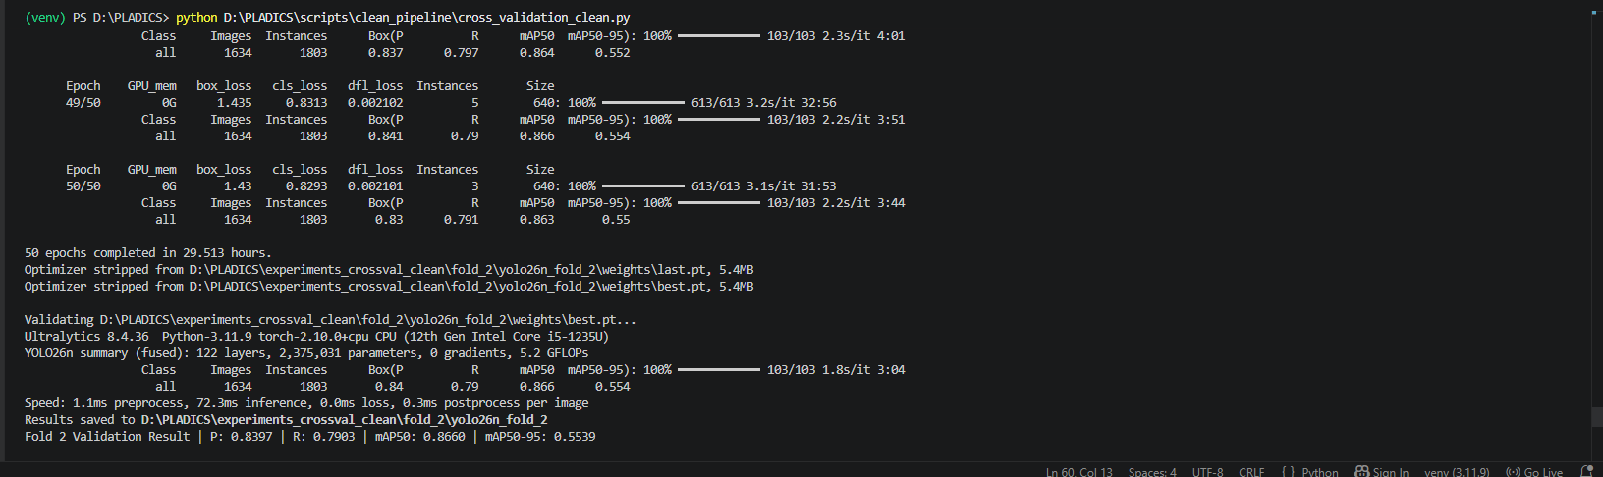
Precision:0.8397
Recall:0.7903
mAP:0.8660
mAP50-95:0.5539

3rd fold result:
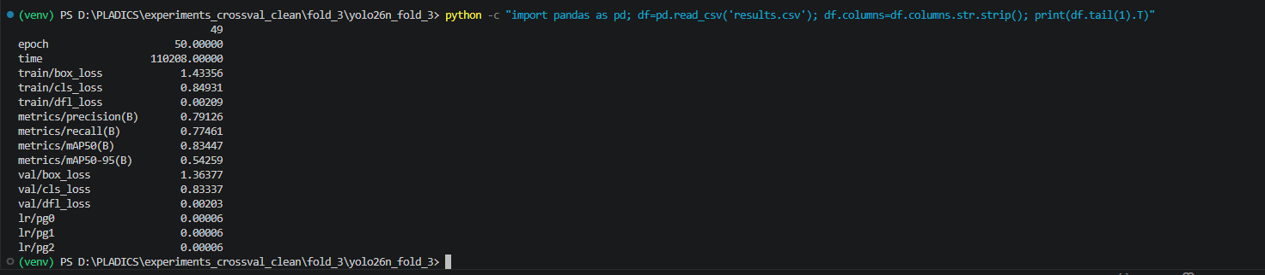
Precision:0.79126
Recall:0.77461
mAP:0.83447
mAP50-95:0.54259

4th fold result:
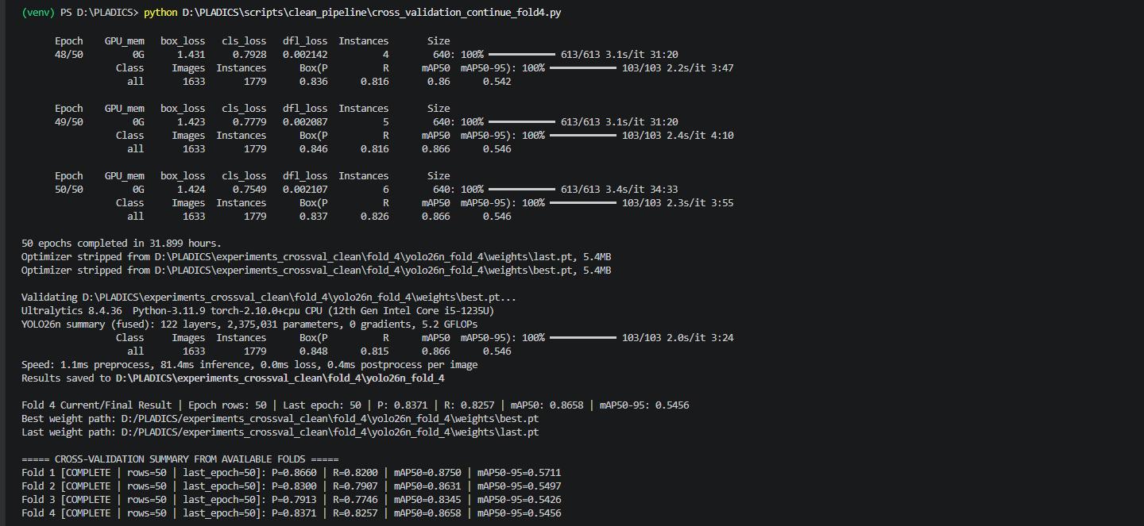

Final Result:
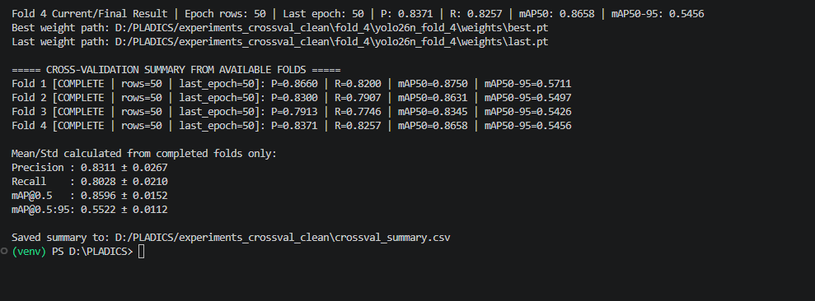

yolo detect train model=D:/PLADICS/yolo26n.pt data=D:/PLADICS/datasets_clean/Riverine_5class_clean/dataset.yaml epochs=50 imgsz=640 batch=4 device=cpu workers=0 project=D:/PLADICS/experiments_multiclass_clean name=riverine5_yolo26n
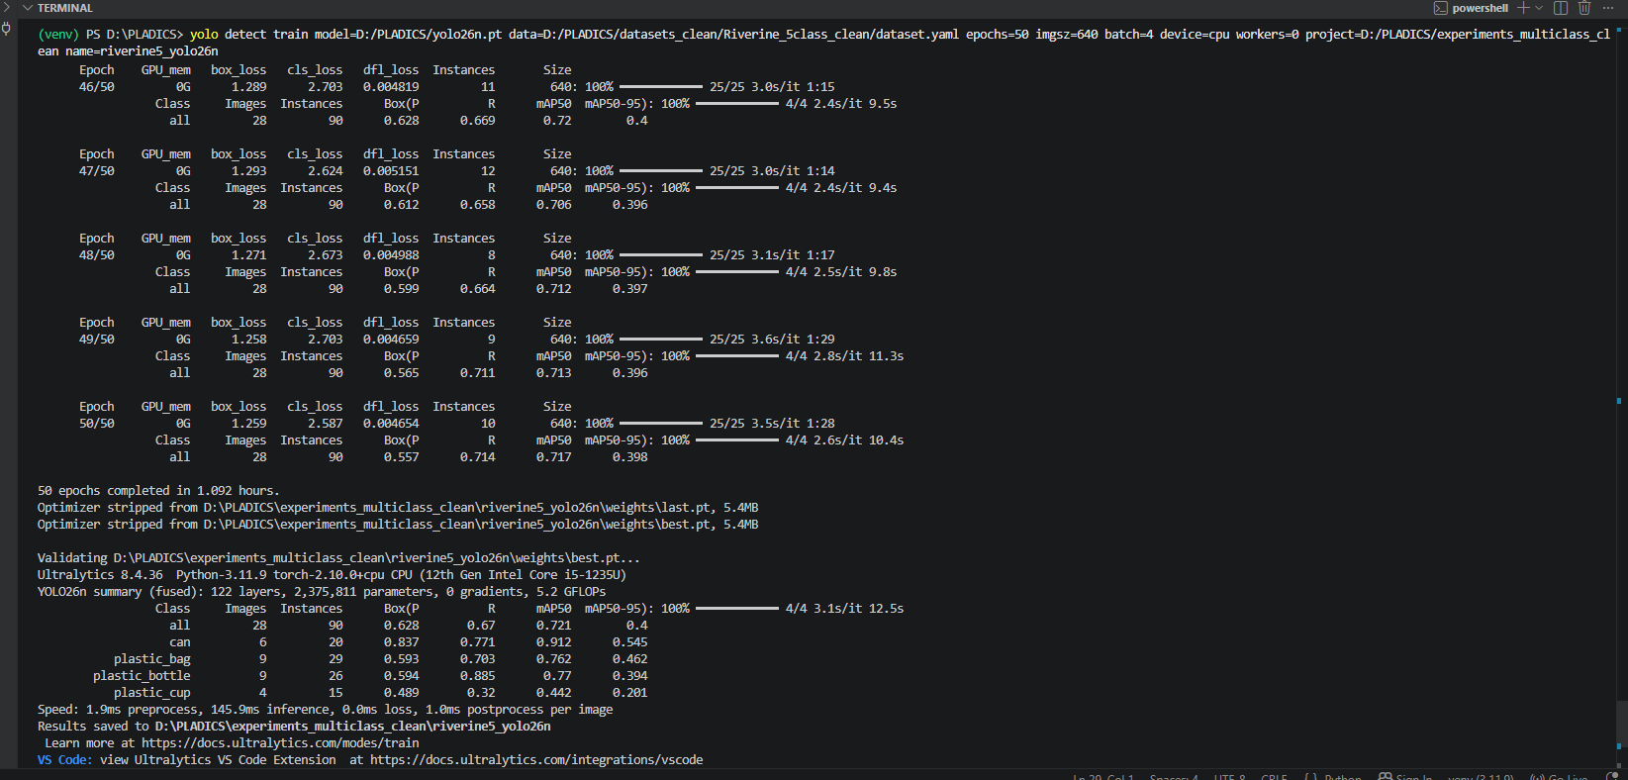
all class Precision:0.628
All class Recall:0.67
All class mAP:0.721
All class mAP50-95:0.4

can class Precision:0.837
can class Recall:0.771
can class mAP:0.912
can class mAP50-95:0.545

Plastic_bag class Precision:0.593
Plastic_bag class Recall:0.703
Plastic_bag class mAP:0.762
Plastic_bag class mAP50-95:0.462

Plastic_bottle class Precision:0.594
Plastic_bottle class Recall:0.885
Plastic_bottle class mAP:0.77
Plastic_bottle class mAP50-95:0.394

Plastic_cup class Precision:0.489
Plaastic_cup class Recall:0.32
Plastic_cup class mAP:0.442
Plastic_cup class mAP50-95:0.201

yolo detect val model=D:/PLADICS/experiments_multiclass_clean/riverine5_yolo26n/weights/best.pt data=D:/PLADICS/datasets_clean/Riverine_5class_clean/dataset.yaml split=test imgsz=640 batch=4 device=cpu workers=0 project=D:/PLADICS/experiments_multiclass_clean name=riverine5_yolo26n_test

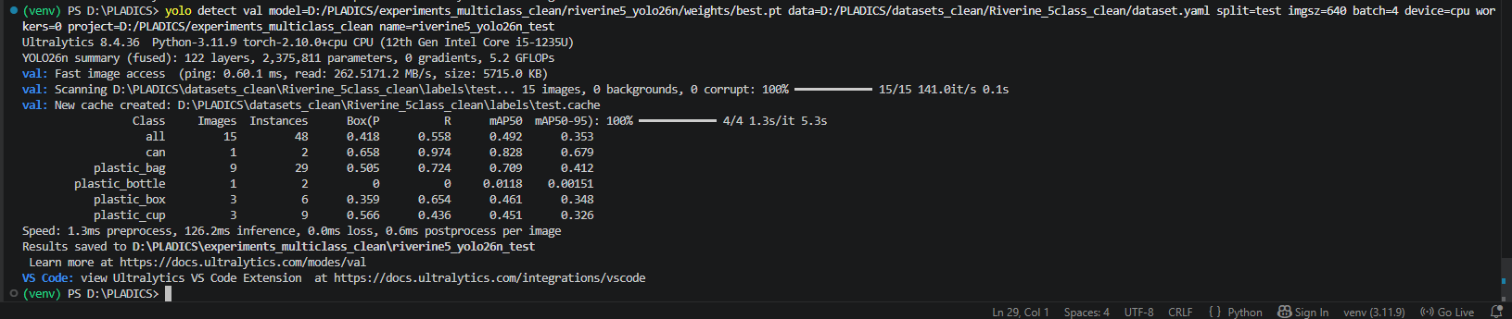

all class Precision:0.418
All class Recall:0.558
All class mAP:0.492
All class mAP50-95:0.353

can class Precision:0.658
can class Recall:0.974
can class mAP:0.828
can class mAP50-95:0.679

Plastic_bag class Precision:0.505
Plastic_bag class Recall:0.724
Plastic_bag class mAP:0.709
Plastic_bag class mAP50-95:0.412

Plastic_bottle class Precision:0.0
Plastic_bottle class Recall:0.0
Plastic_bottle class mAP:0.0118
Plastic_bottle class mAP50-95:0.00151

Plastic_cup class Precision:0.359
Plaastic_cup class Recall:0.654
Plastic_cup class mAP:0.461
Plastic_cup class mAP50-95:0.348
yolo detect predict model=D:\PLADICS\experiments_multiclass_clean\riverine5_yolo26n\weights\best.pt source=D:\PLADICS\datasets_clean\Riverine_5class_clean\images\test imgsz=640 conf=0.25 save=True project=D:\PLADICS\qualitative_results name=riverine_multiclass

Training command:
yolo detect train model=yolov8n.pt data=D:/PLADICS/datasets_clean/merged_clean_dataset/plastic_clean.yaml epochs=50 imgsz=640 batch=8 device=cpu workers=0 project=D:/PLADICS/experiments_clean_final name=yolov8n_clean
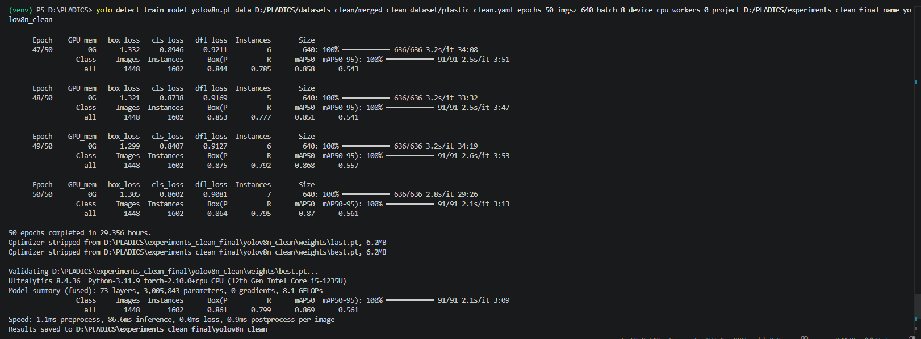

Validate test set:
yolo detect val model=D:/PLADICS/experiments_clean_final/yolov8n_clean/weights/best.pt data=D:/PLADICS/datasets_clean/merged_clean_dataset/plastic_clean.yaml split=test imgsz=640 batch=8 device=cpu workers=0 project=D:/PLADICS/experiments_clean_final name=yolov8n_clean_test

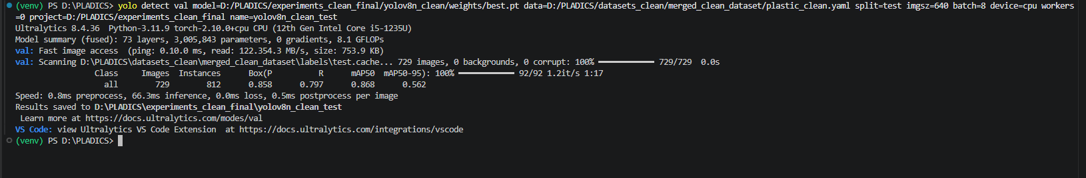

Training command:
yolo detect train model=yolov10n.pt data=D:/PLADICS/datasets_clean/merged_clean_dataset/plastic_clean.yaml epochs=50 imgsz=640 batch=8 device=cpu workers=0 project=D:/PLADICS/experiments_clean_final name=yolov10n_clean
yolo detect val model=D:/PLADICS/experiments_clean_final/yolov10n_clean/weights/best.pt
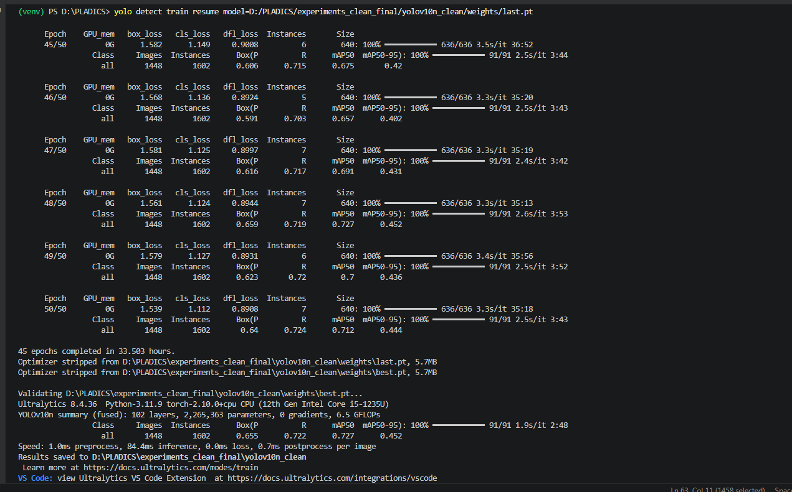

Validate test set:
data=D:/PLADICS/datasets_clean/merged_clean_dataset/plastic_clean.yaml split=test imgsz=640 batch=8 device=cpu workers=0 project=D:/PLADICS/experiments_clean_final name=yolov10n_clean_test
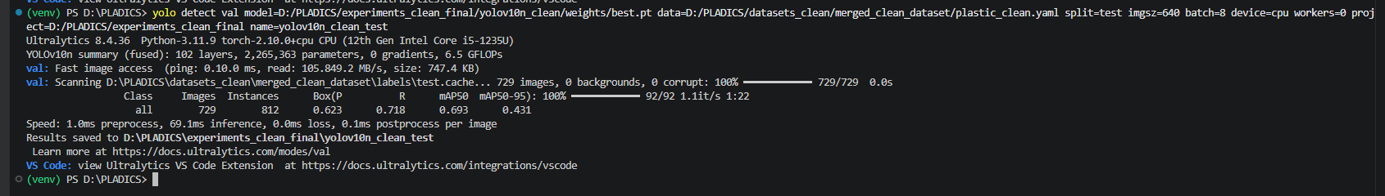

yolo detect train model=D:/PLADICS/yolo26n.pt data=D:/PLADICS/datasets_clean/merged_clean_dataset_75/plastic_clean_75.yaml epochs=50 imgsz=640 batch=8 device=cpu workers=0 project=D:/PLADICS/robustness_tests name=yolo26n_75percent
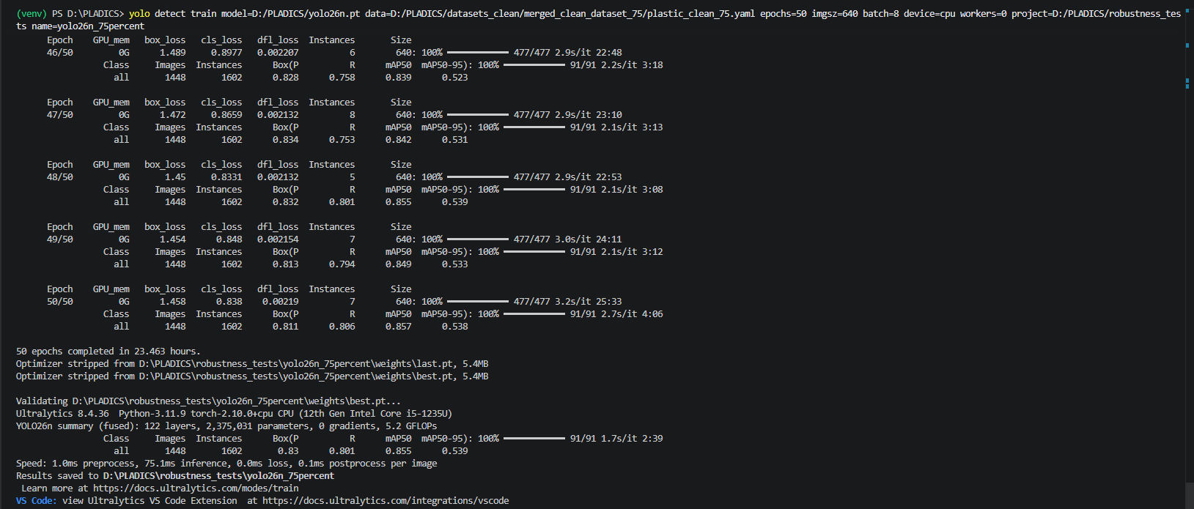
Precision:0.83
Recall:0.801
mAP:0.855
mAP50-95:0.539

yolo detect val model=D:/PLADICS/robustness_tests/yolo26n_75percent/weights/best.pt data=D:/PLADICS/datasets_clean/merged_clean_dataset_75/plastic_clean_75.yaml split=test imgsz=640 batch=8 device=cpu workers=0 project=D:/PLADICS/robustness_tests name=yolo26n_75percent_test
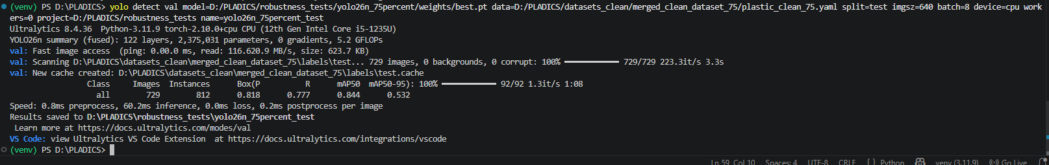
Precision:0.818
Recall:0.777
mAP:0.844
mAP50-95:0.532

Train Command
yolo detect train model=D:/PLADICS/yolo26n.pt data=D:/PLADICS/datasets_clean/merged_clean_dataset_50/plastic_clean_50.yaml epochs=50 imgsz=640 batch=8 device=cpu workers=0 project=D:/PLADICS/robustness_tests name=yolo26n_50percent
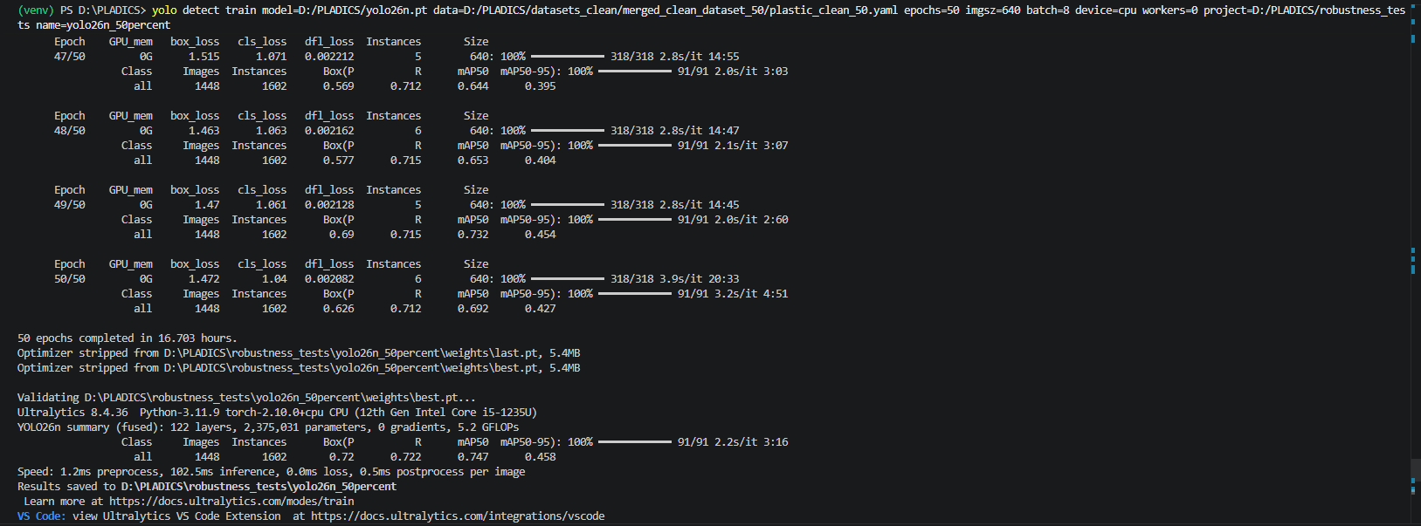

Test Command
yolo detect val model=D:/PLADICS/robustness_tests/yolo26n_50percent/weights/best.pt data=D:/PLADICS/datasets_clean/merged_clean_dataset_50/plastic_clean_50.yaml split=test imgsz=640 batch=8 device=cpu workers=0 project=D:/PLADICS/robustness_tests name=yolo26n_50percent_test
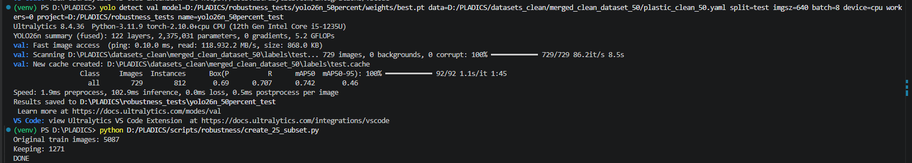

Train Command

yolo detect train model=D:/PLADICS/yolo26n.pt data=D:/PLADICS/datasets_clean/merged_clean_dataset_25/plastic_clean_25.yaml epochs=50 imgsz=640 batch=8 device=cpu workers=0 project=D:/PLADICS/robustness_tests name=yolo26n_25percent
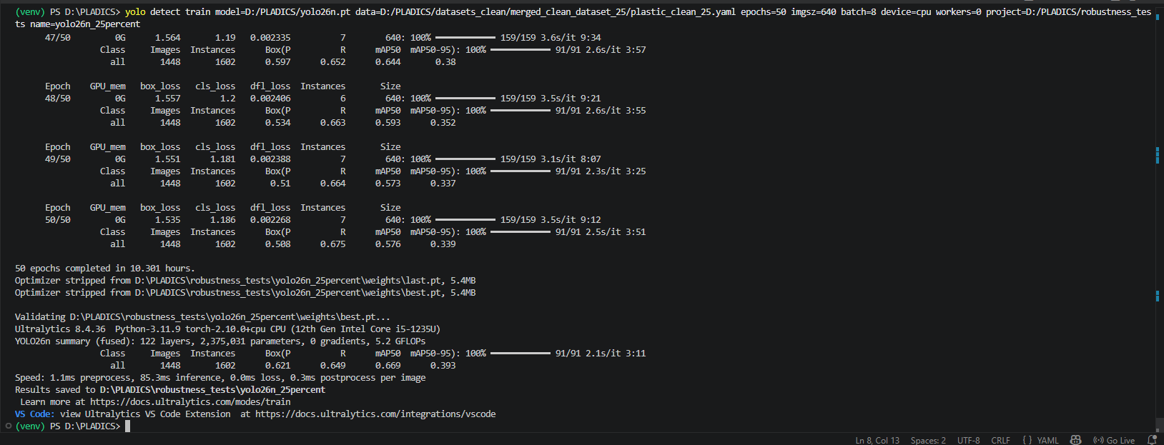

Test Command
yolo detect val model=D:/PLADICS/robustness_tests/yolo26n_25percent/weights/best.pt data=D:/PLADICS/datasets_clean/merged_clean_dataset_25/plastic_clean_25.yaml split=test imgsz=640 batch=8 device=cpu workers=0 project=D:/PLADICS/robustness_tests name=yolo26n_25percent_test
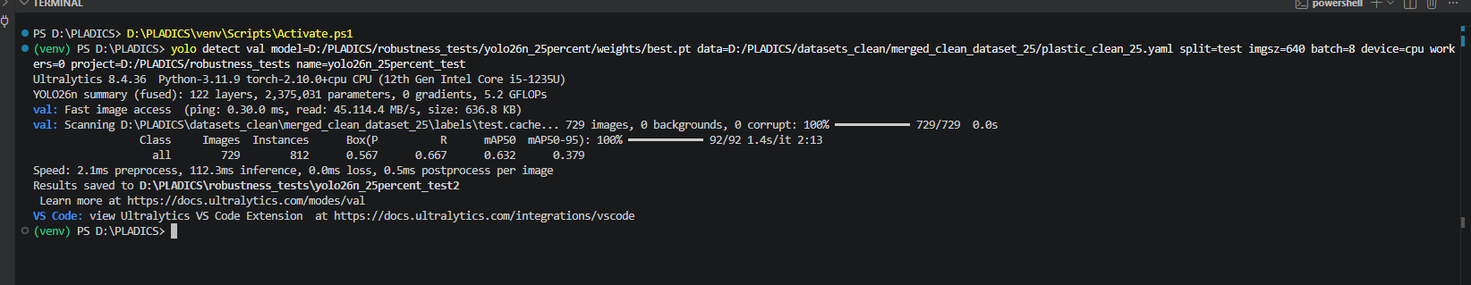

yolo detect train model=rtdetr-l.pt data=D:/PLADICS/datasets_clean/merged_clean_dataset/plastic_clean.yaml epochs=10 imgsz=416 batch=2 device=cpu workers=0 project=D:/PLADICS/experiments_architecture_compare name=rtdetr_l_img416_10epoch
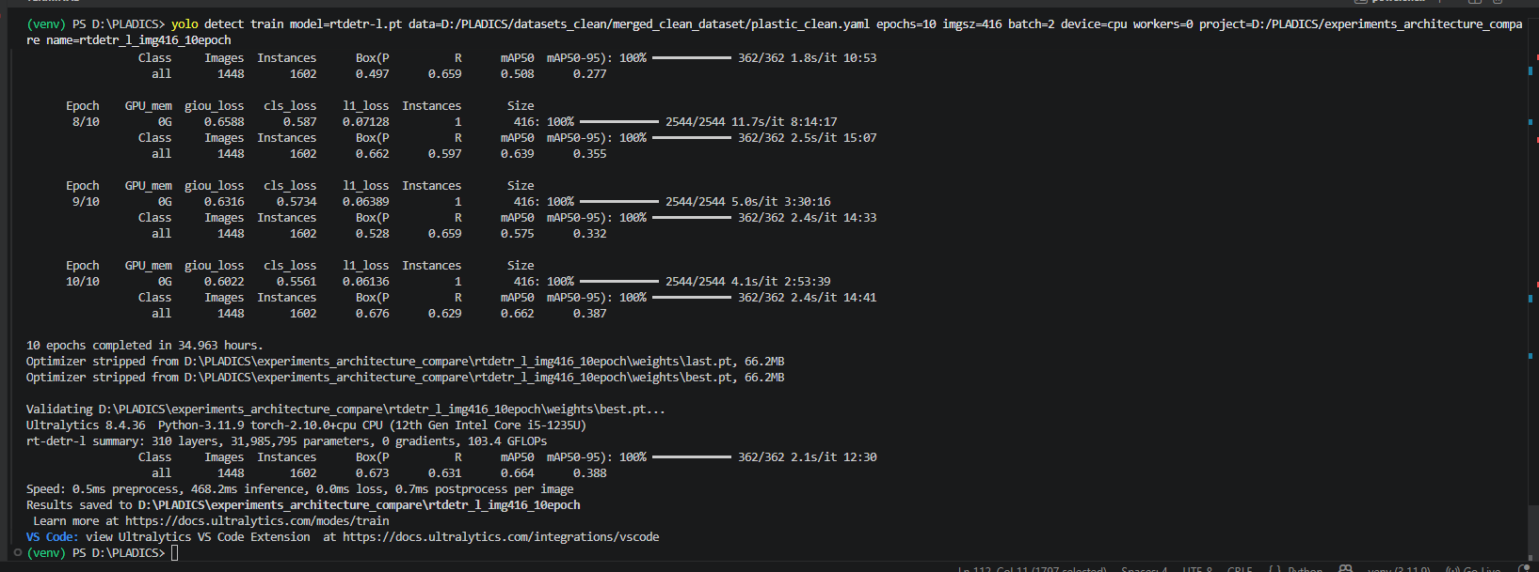
Test Command
yolo detect val model=D:/PLADICS/experiments_architecture_compare/rtdetr_l_img416_10epoch/weights/best.pt data=D:/PLADICS/datasets_clean/merged_clean_dataset/plastic_clean.yaml split=test imgsz=416 batch=2 device=cpu workers=0 project=D:/PLADICS/experiments_architecture_compare name=rtdetr_l_img416_10epoch_test
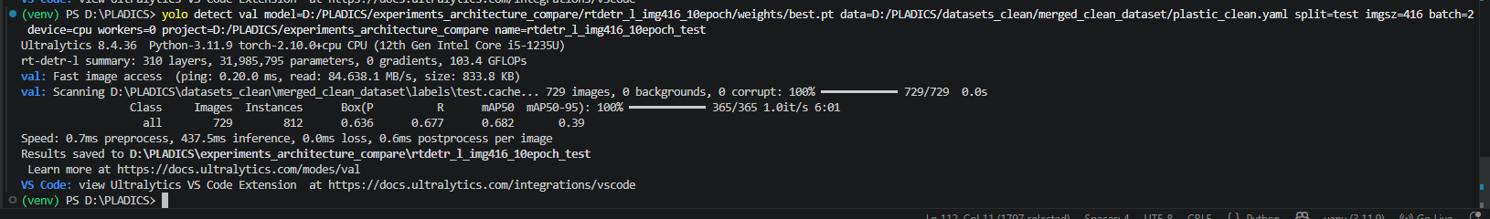

NanoDet results:
10 epochs:
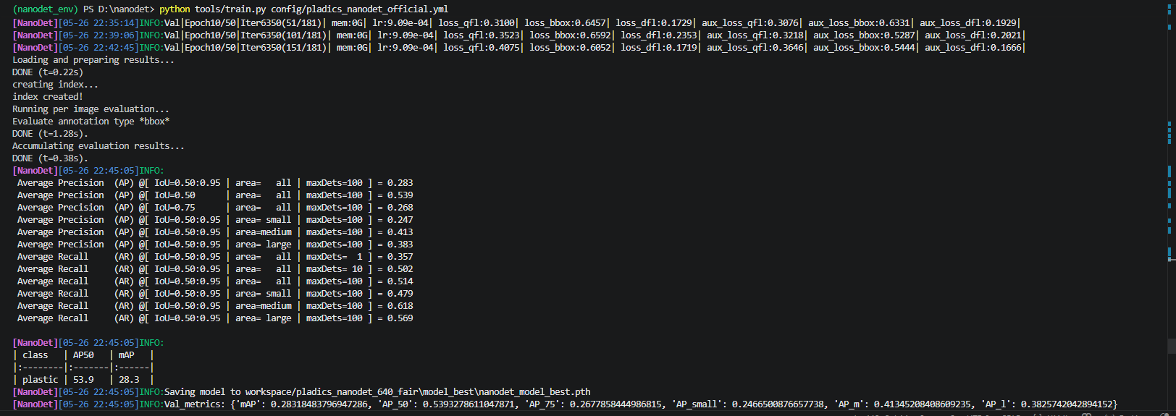
20 epochs:
Get-Content D:\nanodet\workspace\pladics_nanodet_640_fair\model_best\eval_results.txt
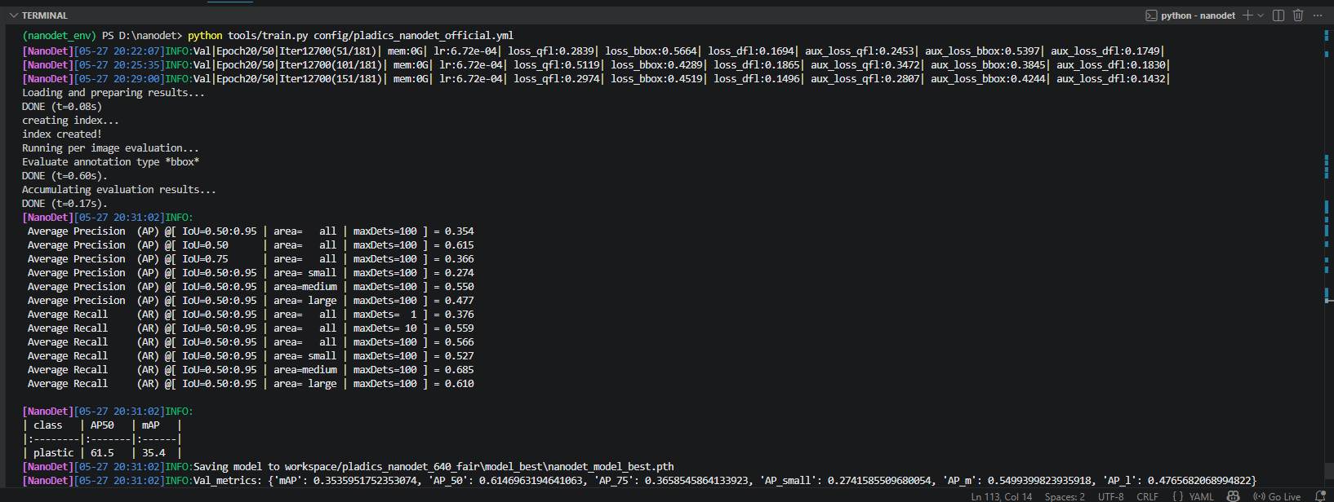
30th epoch:
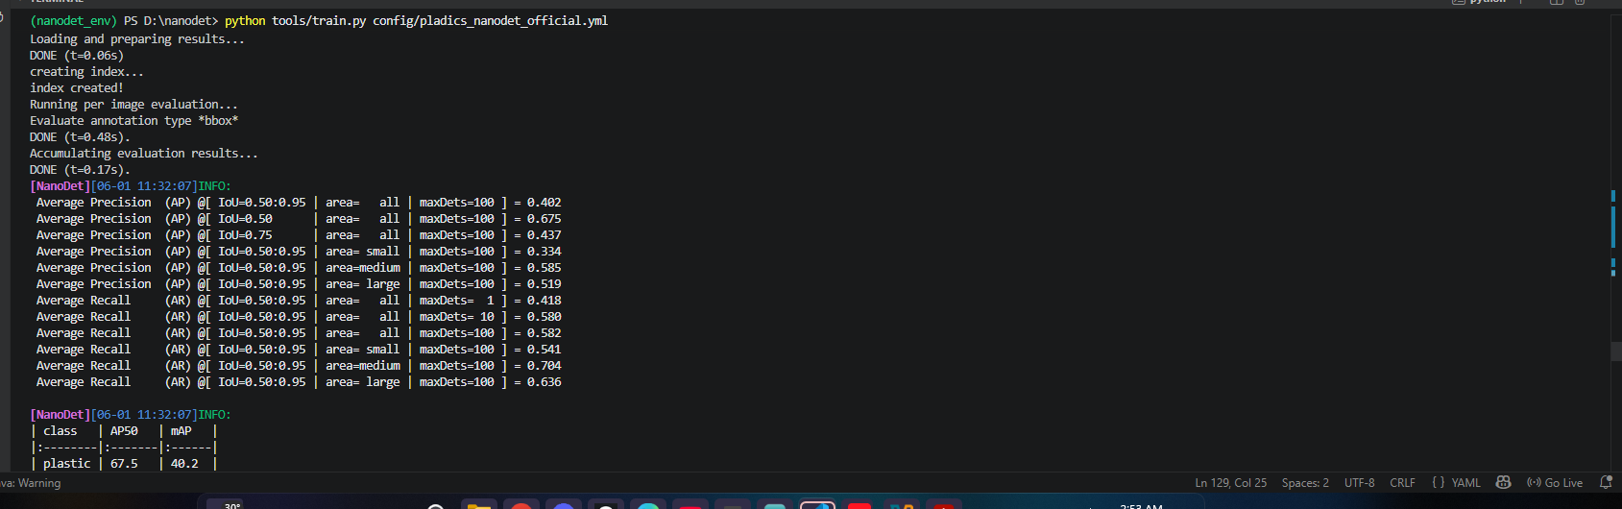
40th epoch:
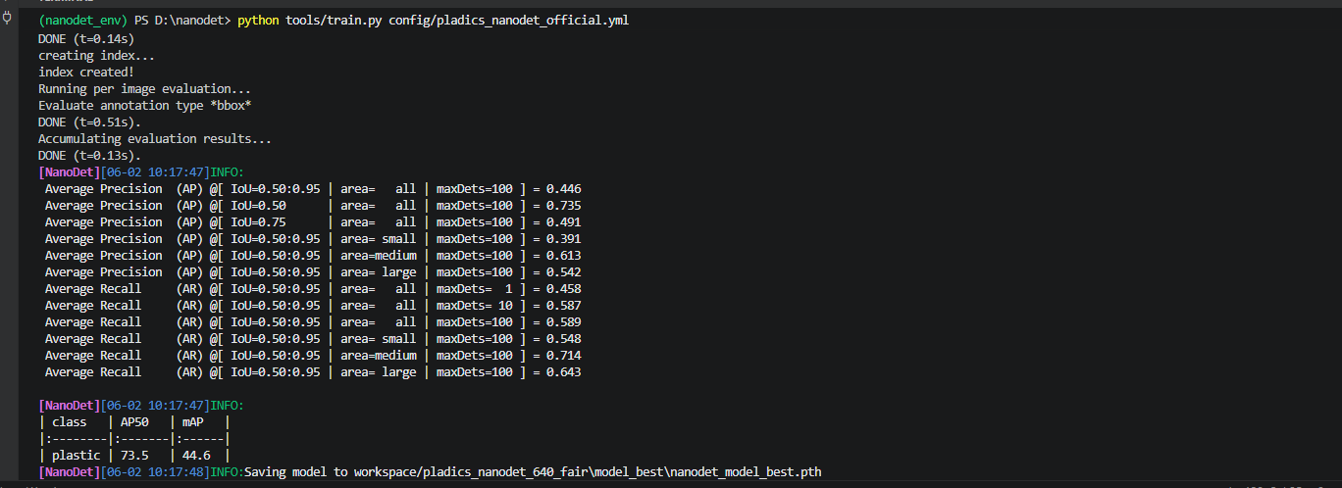
50th epoch:
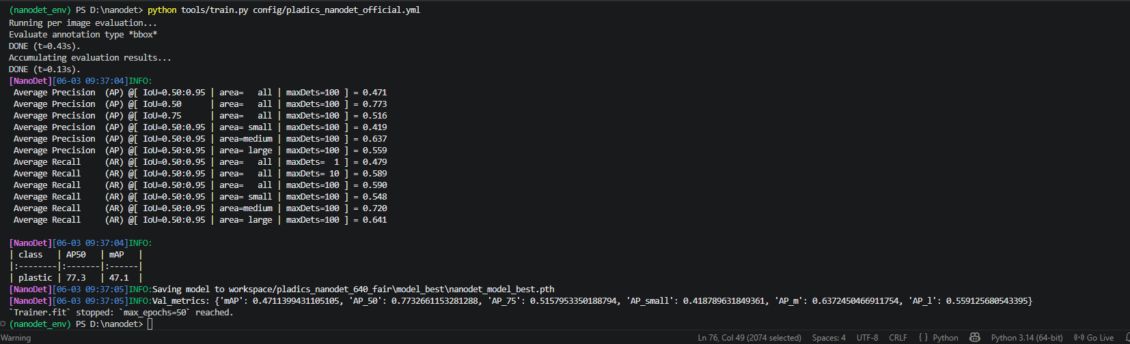
Final result:
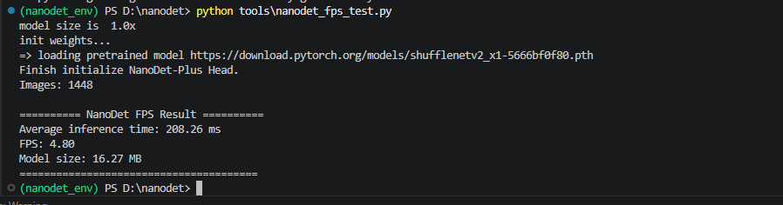
Mobilenetssd
10th epoch:
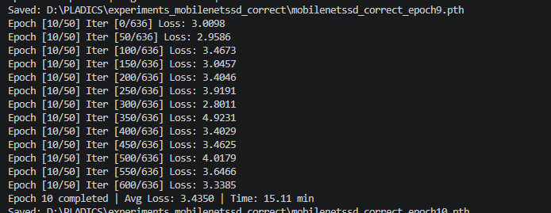

20th epoch:
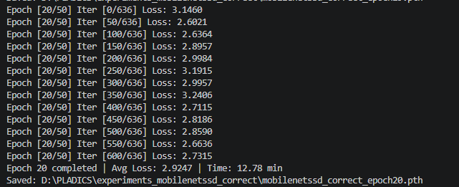
50th epoch:
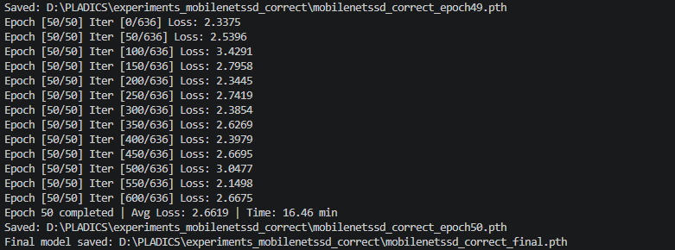
Final result:
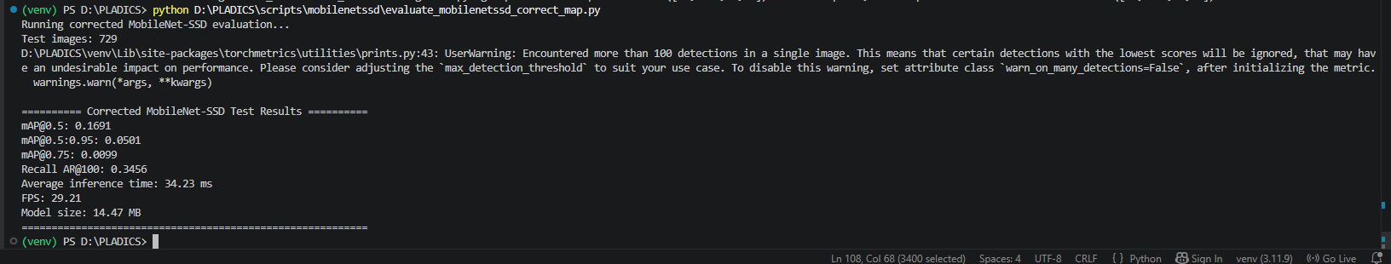

python -c "from ultralytics import YOLO; import os; m=r'D:\PLADICS\experiments_clean_final\yolov8n_clean\weights\best.pt'; r=YOLO(m).val(data=r'D:\PLADICS\datasets_clean\merged_clean_dataset\plastic_clean.yaml',split='test',imgsz=640,batch=1,device='cpu',workers=0,verbose=False); t=r.speed['inference']; s=os.path.getsize(m)/1024/1024; print(f'Inference={t:.2f} ms'); print(f'FPS={1000/t:.2f}'); print(f'Size={s:.2f} MB')"
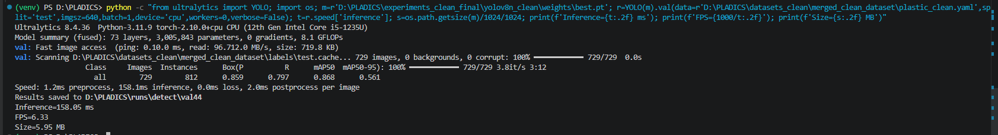

python -c "from ultralytics import YOLO; import os; m=r'D:\PLADICS\experiments_clean_final\yolo11n_clean\weights\best.pt'; r=YOLO(m).val(data=r'D:\PLADICS\datasets_clean\merged_clean_dataset\plastic_clean.yaml',split='test',imgsz=640,batch=1,device='cpu',workers=0,verbose=False); t=r.speed['inference']; s=os.path.getsize(m)/1024/1024; print(f'Inference={t:.2f} ms'); print(f'FPS={1000/t:.2f}'); print(f'Size={s:.2f} MB')"
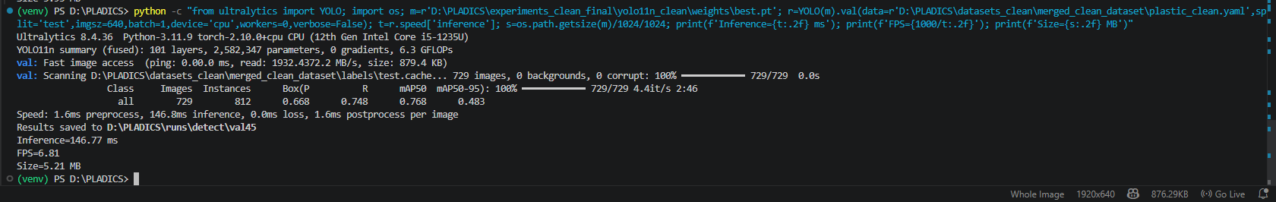
python -c "from ultralytics import YOLO; import os; m=r'D:\PLADICS\experiments_clean\yolo26n_clean\weights\best.pt'; r=YOLO(m).val(data=r'D:\PLADICS\datasets_clean\merged_clean_dataset\plastic_clean.yaml',split='test',imgsz=640,batch=1,device='cpu',workers=0,verbose=False); t=r.speed['inference']; s=os.path.getsize(m)/1024/1024; print(f'Inference={t:.2f} ms'); print(f'FPS={1000/t:.2f}'); print(f'Size={s:.2f} MB')"
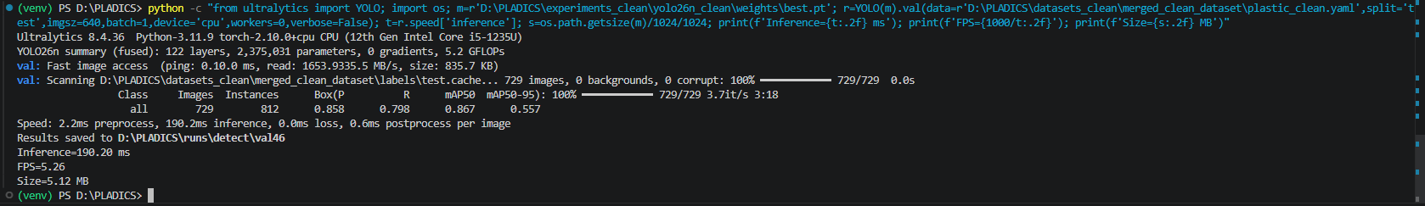
python -c "from ultralytics import YOLO; import os; m=r'D:\PLADICS\experiments_clean\yolo26s_clean\weights\best.pt'; r=YOLO(m).val(data=r'D:\PLADICS\datasets_clean\merged_clean_dataset\plastic_clean.yaml',split='test',imgsz=640,batch=1,device='cpu',workers=0,verbose=False); t=r.speed['inference']; s=os.path.getsize(m)/1024/1024; print(f'Inference={t:.2f} ms'); print(f'FPS={1000/t:.2f}'); print(f'Size={s:.2f} MB')"
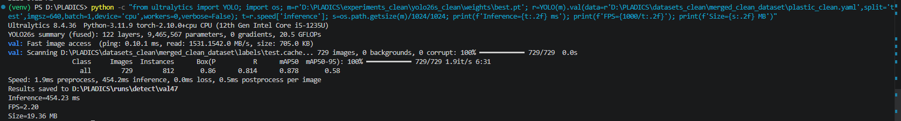

python -c "import pandas as pd; df=pd.read_csv(r'D:\PLADICS\experiments_clean_final\yolov8n_clean\results.csv'); r=df.iloc[19]; print('P=',round(r['metrics/precision(B)'],3)); print('R=',round(r['metrics/recall(B)'],3)); print('mAP50=',round(r['metrics/mAP50(B)'],3)); print('mAP50-95=',round(r['metrics/mAP50-95(B)'],3))"

python -c "import pandas as pd; df=pd.read_csv(r'D:\PLADICS\experiments_clean_final\yolo11n_clean\results.csv'); r=df.iloc[19]; print('P=',round(r['metrics/precision(B)'],3)); print('R=',round(r['metrics/recall(B)'],3)); print('mAP50=',round(r['metrics/mAP50(B)'],3)); print('mAP50-95=',round(r['metrics/mAP50-95(B)'],3))"

python -c "import pandas as pd; df=pd.read_csv(r'D:\PLADICS\experiments_clean_final\yolov10n_clean\results.csv'); r=df.iloc[19]; print('P=',round(r['metrics/precision(B)'],3)); print('R=',round(r['metrics/recall(B)'],3)); print('mAP50=',round(r['metrics/mAP50(B)'],3)); print('mAP50-95=',round(r['metrics/mAP50-95(B)'],3))"

python -c "import pandas as pd; df=pd.read_csv(r'D:\PLADICS\experiments_clean\yolo26n_clean\results.csv'); r=df.iloc[19]; print('P=',round(r['metrics/precision(B)'],3)); print('R=',round(r['metrics/recall(B)'],3)); print('mAP50=',round(r['metrics/mAP50(B)'],3)); print('mAP50-95=',round(r['metrics/mAP50-95(B)'],3))"

python -c "import pandas as pd; df=pd.read_csv(r'D:\PLADICS\experiments_clean_final\yolo26s_clean\results.csv'); r=df.iloc[19]; print('P=',round(r['metrics/precision(B)'],3)); print('R=',round(r['metrics/recall(B)'],3)); print('mAP50=',round(r['metrics/mAP50(B)'],3)); print('mAP50-95=',round(r['metrics/mAP50-95(B)'],3))"

train
yolo detect train model=rtdetr-l.pt data=D:/PLADICS/datasets_clean/merged_clean_dataset/plastic_clean.yaml epochs=20 imgsz=640 batch=4 device=cpu workers=0 project=D:/PLADICS/experiments_architecture_compare name=rtdetr_l_20epoch
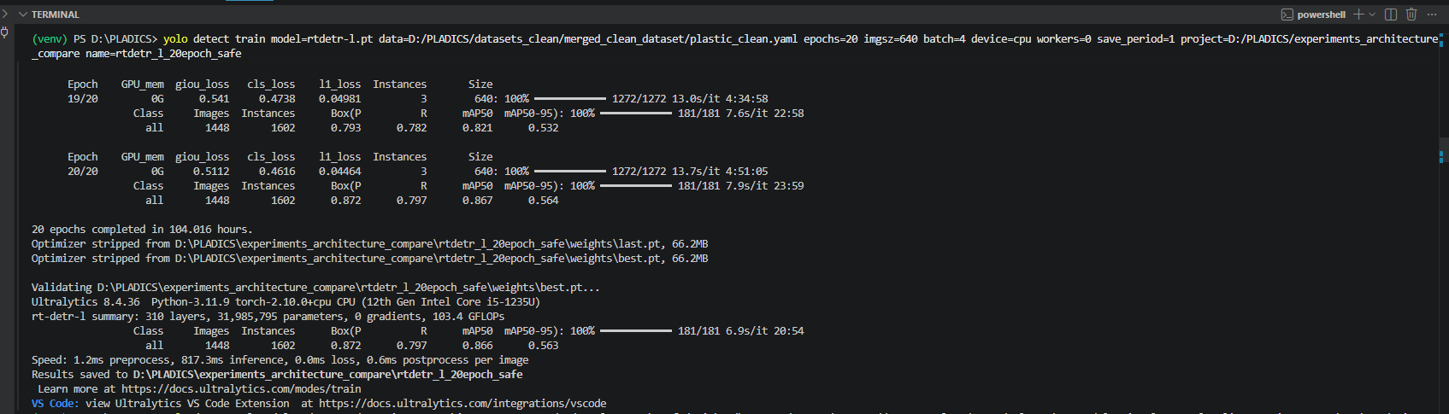

Test command
yolo detect val model=D:/PLADICS/experiments_architecture_compare/rtdetr_l_20epoch/weights/best.pt data=D:/PLADICS/datasets_clean/merged_clean_dataset/plastic_clean.yaml split=test imgsz=640 batch=4 device=cpu workers=0 project=D:/PLADICS/experiments_architecture_compare name=rtdetr_l_20epoch_test
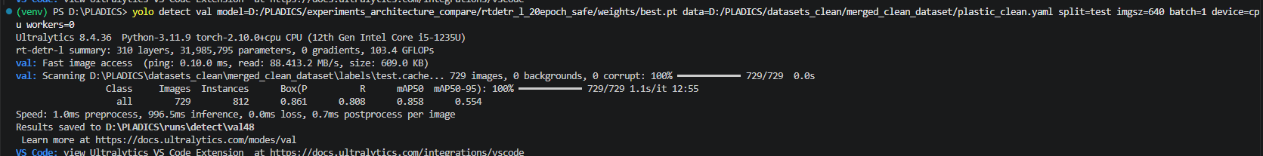
FPS + Inference Time
yolo predict model=D:/PLADICS/experiments_architecture_compare/rtdetr_l_20epoch_safe/weights/best.pt source=D:/PLADICS/datasets_clean/merged_clean_dataset/images/test imgsz=640 device=cpu save=False
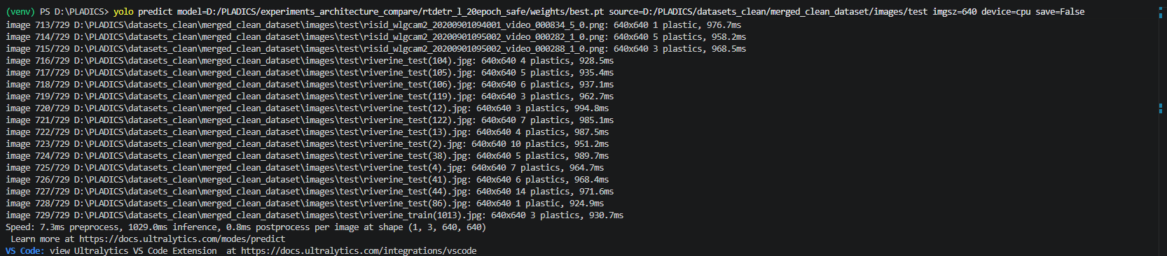
(Get-Item D:\PLADICS\experiments_architecture_compare\rtdetr_l_20epoch_safe\weights\best.pt).Length / 1MB
python -c "from ultralytics import YOLO; import os; m=r'D:\PLADICS\experiments_architecture_compare\rtdetr_l_20epoch_safe\weights\best.pt'; r=YOLO(m).val(data=r'D:\PLADICS\datasets_clean\merged_clean_dataset\plastic_clean.yaml',split='test',imgsz=640,batch=1,device='cpu',workers=0,verbose=False); t=r.speed['inference']; s=os.path.getsize(m)/1024/1024; print(f'Inference={t:.2f} ms'); print(f'FPS={1000/t:.2f}'); print(f'Size={s:.2f} MB')"
